Screening of Dysgraphia in Preadolescent Children using Machine Learning

Ch.Mandakini1, Dr. M. Seetha2,G.Prathyusha³,G.Charishma⁴ ,G.TharunyaVarma⁵,V.Rakshitha⁶
Assistant Professor ¹, Professor², B.Tech Student ^{3,4,5,6}
Department of CSE, G.Narayanamma Institute of Technology and Science (for women)
Shaikpet, Hyderabad-500104, Telangana, India.
mandakinireddy@gnits.ac.in,maddala.seetha@gnits.ac.in,prathyushagaddam00@gmail.com,gandecharishma3@gmail.com, tharunyavarma@gmail.com,rakshithareddy265@gmail.com.

Abstract:
Dysgraphia is a learning disorder characterized by difficulties with writing, particularly with spelling, grammar, punctuation, and handwriting. Handwriting analysis plays a crucial role in detecting dysgraphia. It is imperative to detect dysgraphia at early stages to improve individuals writing skills, promote better self-esteem and mental well-being and develop a technology-based solution to help individuals with dysgraphia overcome the challenges that they struggle in organizing their thoughts or become anxious. The aim is to develop a dysgraphia detection system using supervised machine learning algorithms that builds upon previous research and leverages various techniques to enhance the detection of dysgraphia. The supervised Machine Learning algorithms are trained and tested with various split ratios (60-40,70-30,80-20) on a dataset collected from children between the ages of 7 to 12 years. To ensure a robust and balanced dataset, a variety of data augmentation strategies are used to get over the limited availability of handwriting data. The developed system achieves highest accuracy 97.61% for AdaBoost Classifier to detect dysgraphia in children's handwriting data.

Keywords: Dysgraphia, learning disorder, machine learning, handwriting

1. Introduction
Dysgraphia is a significant learning disorder with wide-ranging effects, including academic struggles and mental health challenges. It is a learning disability that affects a student's ability to write coherently and legibly, particularly in the early stages of education when writing skills are being developed. The need for accurate screening is important, especially in rural areas with limited awareness as the literacy rate is gradually low as a result teachers and parents are in need to not only concentrate on student’s academics but also on the abilities. Technology advancements have shown promise in bridging the socio-economic gap by enabling remote testing with algorithms like random forests and neural networks. Early detection is crucial because it is the age where drastic changes occur in handwriting learnings given the economic constraints and limited expertise in existing testing scales. This study focuses on developing model for dysgraphia screening, considering handwriting features, using supervised machine learning and data augmentation techniques. Accurate detection is crucial, especially in rural areas with limited awareness. Symptoms of dysgraphia may include poor legibility, irregular letter shapes, slow writing speed, and difficulty with spelling. Emotional challenges like lower self-esteem and anxiety can occur, especially when students struggle to meet academic expectations. Dysgraphia can be difficult to detect, and individuals may hide their disability [1].

This condition can have various impacts on students, may experience difficulties in forming letters and shapes, leading to illegible handwriting and hindering effective communication and accurate assessment by teachers. Dysgraphia can cause slow writing speed, leading to frustration andchallenges in completing assignments within given time frames, potentially affecting academic performance. Organizing thoughts and expressing ideas coherently on paper can be challenging for students with dysgraphia. Poor spelling and grammar may result from difficulties recalling correct letter sequences and grammatical rules. Students may become reluctant to write due to the challenges they face, impacting their overall engagement in learning and motivation for written assignments. Emotionally, dysgraphia can lead to frustration, embarrassment, and anxiety, potentially causing social isolation and negatively affecting self-esteem.

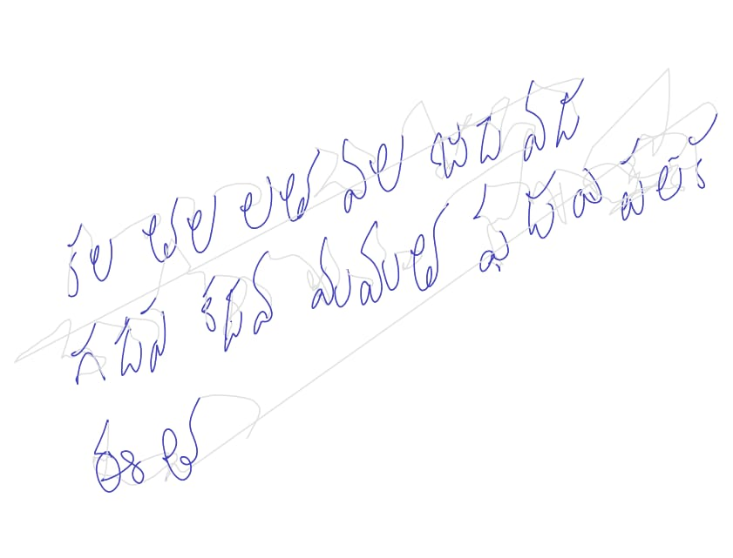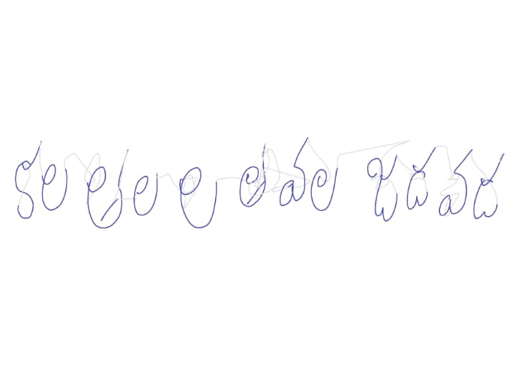
Fig-1 Samples of Dysgraphic Handwriting.
Fig-1 shows the samples of dysgraphic handwriting which depicts that there is inconsistent letter spacing and slow writing speed. The importance of early dysgraphia detection has been emphasized, highlighting the economic constraints and ambiguity of current testing scales that require expert intervention. Additionally, existing systems often overlook the motor aspects of handwriting, which are crucial for accurately classifying dysgraphia. Early detection is emphasized due to economic constraints and overlooked motor aspects of handwriting in existing systems. The proposed system offers a simple, efficient, and cost-effective solution, addressing the need for early intervention, particularly in areas with limited psychological assistance. The findings can contribute to raising awareness, improving diagnostic accuracy, and providing timely support for individuals with dysgraphia. Teachers and schools can identify students with dysgraphia more effectively, leading to personalized educational plans and strategies which can improve their academic performance.

Researchers focused on addressing the issues related to handwriting quality and dysgraphia in children in order to enhance the children’s handwriting skills and overall academic progress.
Thomas Gargot et al. [2] assessed handwriting in 280 children using digital tablets and the BHK test. They extracted 12 digital features and found that certain features were associated with changes in handwriting quality in typically developing children. They also identified differences in features between children with and without dysgraphia, offering insights for automatic dysgraphia detection and therapeutic opportunities. The development of handwriting skills over the course of education was then studied using linear models built using these features.
Peter Drotár & Marek Dobes [3] used automated procedures and machine learning to detect dysgraphia in handwriting with nearly 80% accuracy. They collected a diverse handwriting dataset, extracted various features, and found that AdaBoost performed the best among algorithms, offering potential for widespread dysgraphia testing and early intervention. This approach allows for wider dysgraphia testing and early intervention possibilities The findings demonstrate how machine learning may be used to accurately identify dysgraphia.
Linda Greta Duil et al. [4] developed a novel method to identify potential handwriting problems in children before they learn to write by analyzing their drawings. Their machine learning model achieved a sensitivity of 0.75 and specificity of 0.76, enabling early intervention for children at risk of handwriting learning delays. By implementing this system, early intervention to train specific learning delays will become feasible, enabling teachers and specialists to address handwriting difficulties promptly and provide necessary support to children with potential learning challenges.
Thibault Asselborn et.al [5] concentrated on the relationship between children's behavioral and academic development and the prompt acquisition of reading and writing skills, especially in dysgraphia instances. They developed a diagnostic tool utilizing 53 handwriting features, achieving impressive sensitivity (96.6%) and specificity (99.2%) for dysgraphia assessment.
Begum et al. specialized in digital pen-tablet sensor data processing for real-time handwriting data analysis for user authentication. It introduces an optimal feature selection technique to improve the performance of user identification systems by extracting kinematic and statistical features from handwriting.

Despite the notable strides made in the existing approaches, certain critical gaps still exist. Firstly, there is a significant imbalance in the dataset, which can potentially skew the results and hinder the generalizability of the models. Secondly, studies have often treated the entire age range of 7 to 12 as a single homogeneous group when constructing their models which gave less than 80% accuracy. Recognizing and addressing these gaps could lead to more robust and precise approaches in the realm of handwriting assessment and dysgraphia detection.

2. Methodology
The proposed methodology follows a structured flow to develop a dysgraphia detection model using supervised machine learning algorithms which are trained on a dataset collected from the children between the age group 7-12 years. This involves a series of steps for screening of dysgraphia which includes collection of handwriting samples from preadolescent children which are then processed to extract relevant features that represent different aspects of the handwriting. The dataset is preprocessed to handle missing values, outliers, and noise. Preprocessing may also involve normalizing or standardizing the features to ensure they have a consistent scale. Data is often divided into training and testing sets for model evaluation. The core of architecture is about machine learning model used for dysgraphia detection where 5 different classifiers are used for screening of dysgraphia. Evaluation criteria that are acceptable are used to assess the trained model (e.g., accuracy, recall, precision, F1-score).

Handwriting Dataset
Data Preprocessing
Data Augmentation

Machine learning
model

AdaBoost algorithm
Decision Tree

XG Boost algorithmm

Random Forest
Naïve Bayes

Model Evaluation

Non-Dysgraphic
Dysgraphic

Fig-2 Architecture of model using handwriting dataset.

Architecture of model shown in Fig-2 that depicts about screening of dysgraphia in 4 major steps which involves collection of handwriting dataset, data preprocessing, data augmentation, building machine learning model and model evaluation.

3. Implementation

3.1 Data Collection

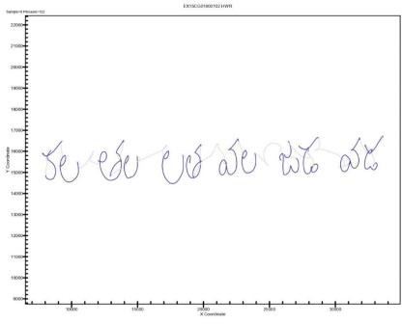
The handwriting samples were collected from two schools with 82 school children between age group 8-12 years old as specifically shown in Table 2. The data was collected using a graphical tablet connected to a computer. Each participant were given an assignment to write a few words in Telugu specified along with few figures [6] were also drawn as a part of assignment.
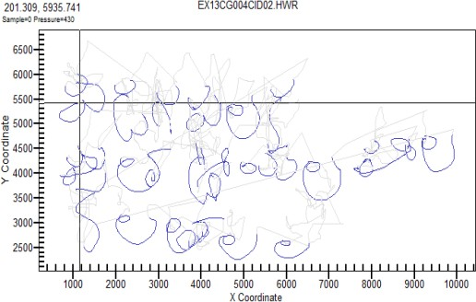

i. Dysgraphic ii. Non-Dysgraphic
Fig-3 Samples of collected data.

Collected handwriting samples are shown in Fig-3 where first figure depicts sample of dysgraphic child and second depicts sample of non-dysgraphic child.

Table 2: Table of statistics of collected handwriting data.

Grade | Number of students | Gender | Dysgraphic count | Non-dysgraphic count
3 | 27 | Male-16 | 6 | 10
3 | 27 | Female-11 | 2 | 9
4 | 36 | Male-18 | 2 | 16
4 | 36 | Female-18 | 3 | 15
5 | 19 | Male-11 | 0 | 11
5 | 19 | Female-8 | 0 | 8
Total | 82 | Male-45 | 13 | 69
Total | 82 | Female-37 | 13 | 69

Table 2 statistics of collected handwriting data shows that there are 82 students in total, with 45 males and 37 females. Out of these, 13 students are identified as dysgraphic, while 69 students are classified as non-dysgraphic.

3.2 Data Preprocessing

Data is collected using the graphical tablet and processed it to extract various features from the handwriting data. Extracted data is numerical data in tabular form which has various features [7] extracted by from the handwriting that counts down to 32 features. Out of all 32 features only few are relevant to the current task of dysgraphia detection via handwriting analysis [8]. Thus, the total number of features are narrowed down to 11 which are Start time, Duration, Start Vertical Position, Vertical Size, Peak Vertical Acceleration, Peak Vertical Velocity, Slant, Average Pen Pressure, Loop Surface, Average Absolute Velocity.

Preprocessing of time-series data to discrete data is done through technique called equal frequency distribution to make the data suitable to apply machine learning algorithms. Equal frequency discretization divides the data intointervals with an equal number of observations, which can be useful when the data is skewed or has outliers. This technique ensures that each bin contains approximately the same number of observations, which can help to minimize the impact of outliers or unusual datapoints.

  - Model Building

Screening of Dysgraphia is implemented by various classification algorithms [9] which includes Decision Tree, Random Forest, Naïve Bayes, boosting algorithms [10] such as XG Boost classifier, AdaBoost classifier. The handwriting dataset consists of 13 classifications of dysgraphia and 69 classifications of non-dysgraphia which is used to build the model after the feature extraction and processing of data.
Decision Tree Classifier
Decision trees are a popular machine learning algorithm used for both classification and regression tasks. They build a structure that resembles a hierarchical tree, with each node standing for a feature and a data-driven split point. A decision tree algorithm divides the data into subsets at each internal node by choosing a feature and a threshold value. Objective is to create splits that best separate the data based on the target variable (for classification, this is often class labels; for regression, it's a numerical value). At each node of the tree, the algorithm determines the feature that best divides the data into dysgraphic and non-dysgraphic samples according to the criteria called Gini impurity. The process keeps going till the stopping criterion is satisfied which is implemented using sklearn.tree library.
Random Forest Classifier
Random Forest is a highly regarded ensemble learning algorithm in the field of machine learning. It operates by combining multiple decision trees, making it a robust choice for both classification and regression tasks. It creates subsets of the training data with replacement using a method known as bagging, enabling each tree to learn from marginally different data samples. Moreover, Random Forest introduces randomness by selecting a random subset of features at each node for splitting, reducing the risk of overfitting and enhancing the model's generalization capabilities. In classification tasks, it employs a majority voting mechanism among constituent trees, while for regression, it averages the outputs. The sklearn.ensemble module is used in Python to create the Random Forest classifier in this machine learning model.
Naïve bayes Classifier
Naive Bayes is a simple classifier yet effective probabilistic machine learning technique which is mostly used for classification problems. It is predicated on the conditional independence of features and the Bayes theorem, which is useful in practice. Using the likelihood that a feature would occur within a class, Naive Bayes determines the chance that a data point belongs to that class. Despite its simplicity, Naive Bayes often performs admirably and is computationally efficient, which makes it well-suited for complex datasets. It is particularly suitable for text-based classification tasks hence it can be used for handwriting analysis. The Naive Bayes in this machine learning model is implemented in python using sklearn.naive_bayes library.
XG Boost Algorithm
XGBoost, short for Extreme Gradient Boosting, is a cutting-edge machine learning algorithm that has gained immense popularity for its exceptional predictive performance and versatility. It belongs to the family of ensemble methods, specifically gradient boosting, and excels in both classification and regression problems. XGBoost leverages a boosting technique that sequentially combines a multitude of weak learners, typically decision trees, to create a strong predictive model. It goes a step further by addressing some of the shortcomings of traditional gradient boosting methods, such as overfitting and slow training times. By using regularization techniques and a specialized objective function, XGBoost effectively manages model complexity, preventing overfitting. Additionally, it offers superior handling of missing data, can incorporate user-defined custom loss functions, and provides feature importance scores to aid in feature selection. The Gradient Boosting classifier in this machine learning model is implemented in python using sklearn.ensemble library.

AdaBoost Algorithm
AdaBoost [11] short for Adaptive Boosting, is a powerful ensemble learning algorithm widely used in machine learning for classification problems. It works by gradually training a number of unreliable classifiers, such as decision stumps (shallow decision trees), and assigning them different weights based on their performance. The algorithm focuses on correctly classifying the samples that previous classifiers have misclassified, adjusting the data distribution to give more weight to the challenging instances. This adaptive nature allows AdaBoost to continually improve its performance with each weak learner added to the ensemble. In the end, to determine the final classification, AdaBoost aggregates the predictions of these weak classifiers using a weighted majority vote. AdaBoost is known for its ability to handle complex datasets, avoid overfitting, and achieve higher accuracy, even with relatively simple base classifiers. The AdaBoost classifier in this machine learning model is implemented in python using sklearn.ensemble library .

Model is trained using these algorithms considering distinct train-test split ratios (80-20,70-30,60-40) where 70-30 split was identified as the optimal reference ratio for subsequent processing due to its better performance for most of the algorithms. Since the performance of the model is below 80%, it is necessary to balance the handwriting dataset.

But the collected dataset is highly imbalanced, consisting 13 classifications of Dysgraphia out of a total of 82 participants. This bias in the dataset will lead to a higher probability that a participant will be classified as not having Dysgraphia. To prevent this, the data augmentation [12] technique such as Random Smote is used that gives a weight of 50 times more to a Dysgraphia diagnosis than a non-dysgraphia diagnosis to balance the training of the model.

Random SMOTE

It is a method that seeks to achieve a balance in the distribution of classes by duplicating instances from the minority class that involves introducing randomness into the process of generating synthetic samples using the SMOTE algorithm. This might include randomly selecting neighbors, varying interpolation methods, or introducing controlled noise during sample creation. The aim would be to enhance the diversity and effectiveness of synthetic samples.
After applying the above data augmentation techniques, dysgraphic data has been increased from 16% to 50% so that the dataset is balanced in terms of positive and negative samples. The data has been subjected to the supervised machine learning algorithms consisting of 64-dysgraphic and 64- Non-dysgraphic samples out of which AdaBoost algorithm outperforms the remaining algorithms.

4. Results and Discussions
The performance of the algorithms is analyzed using performance measures [13] like accuracy, precision, recall, F1-Score. By considering these metrics, model’s strengths and weaknesses are assessed and compared with the performance of different algorithms.
The AdaBoost Classifier with Random SMOTE gave better accuracy 97.61%, compared remaining algorithms is that AdaBoost gives more weight to the training instances that are misclassified by the weak classifiers in each iteration, thereby focusing on the hard examples and improving classification performance. This iterative nature makes AdaBoost to focus on the previously underrepresented minority class, resulting in better performance with the effect of data augmentation technique Random SMOTE.

Table 3: Performance Analysis of various algorithms before and after augmentation techniques

Algorithm | Before Augmentation |  |  |  | After Augmentation (Random Smote)
Algorithm | Accuracy | Precision | Recall | F1 Score | Accuracy | Precision | Recall | F1Score
Decision Tree classifier | 76% | 0.72 | 0.76 | 0.74 | 95.24% | 0.96 | 0.95 | 0.95
Random Forest Classifier | 80% | 0.64 | 0.80 | 0.71 | 96.43% | 0.97 | 0.96 | 0.96
Naïve bayes Classifier | 76% | 0.63 | 0.76 | 0.69 | 80.95% | 0.87 | 0.83 | 0.83
XG Boost Classifier | 78.79% | 0.76 | 0.79 | 0.77 | 95.23% | 0.94 | 0.93 | 0.93
AdaBoost Classifier | 70.59% | 0.76 | 0.71 | 0.73 | 97.61% | 0.98 | 0.98 | 0.98

Table 3 compares the performance of different Machine Learning classifiers before and after data augmentation using Random SMOTE. Before augmentation, all classifiers had varying levels of accuracy, precision, recall, and F1 scores on the dataset. After augmentation, there was a significant improvement in performance across all classifiers, with higher accuracy, precision, recall, and F1 scores, indicating that model's ability to make predictions was improved by data augmentation.

5. Conclusions
In conclusion, the proposed architecture for dysgraphia screening presents a comprehensive workflow that encompasses key steps, in which the handwriting data was collected from children aged 7 to 12 years from 2 ruralschoolsusinggraphicaltablet connected to a computer,features are extracted and 11 significant features are identified, a model that can detect dysgraphia in children through handwriting analysis using machine learning techniques is developed and model’s performance is assessed using metrics like accuracy, precision, recall and support. Since accuracy of the model is not greater than 80% when trained with machine learning techniques namely Decision Tree, Random Forest, Naïve Bayes, XGBoost and AdaBoost classifiers, data augmentation techniques such as Random SMOTE is applied to ensure a balanced dataset consisting of 64-dysgraphic and 64-nondysgraphic samples. TheAdaBoost classifier hasshownmaximum accuracy 97.61% for random smote augmentation technique when trained using handwriting dataset. Dysgraphia screening offers advantages to preadolescent children by enabling early identification of handwriting difficulties, allowing timely intervention and support for improved academic and psychosocial outcomes.

6. References

[1] Richards, R. G. Te Source for Dyslexia and Dysgraphia (LinguiSystems, East Moline, 1999).
[2] Asselborn, T., Gargot, T., Kidziński, Ł. et al. Automated human-level diagnosis of dysgraphia using a consumer tablet. npj Digital Med 1, 42 ,2018.
[3] Drotár, P., Dobeš, M. Dysgraphia detection through machine learning. Sci Rep 10, 21541 ,2020.
[4] Dui, L.G., Lomurno, E., Lunardini, F. et al. Identification and characterization of learning weakness from drawing analysis at the pre-literacy stage. Sci Rep 12,21624,2022.
[5] Gargot, Thomas & Asselborn, Thibault & Pellerin, Hugues &Zammouri, Ingrid & Anzalone, Salvatore &Casteran, Laurence & Johal, Wafa&Dillenbourg, Pierre & Cohen, David & Jolly, Caroline,2020. Acquisition of handwriting in children with and without dysgraphia: A computational approach. PloS one. 15. e0237575. 10.1371/journal.pone.0237575.
[6]Dui, L.G., Lomurno, E., Lunardini, F. et al. Identification and characterization of learning weakness from drawing analysis at the pre-literacy stage. Sci Rep 12,21624,2022.
[7] Kohavi, R. & John, G. H. Wrappers for feature subset selection. Artif. Intell. 97, 273–324 (1997).
[8]Mekyska, J. et al. Identifcation and rating of developmental dysgraphia by handwriting analysis. IEEE Trans. Hum. Mach. Syst. 47, 235–248 (2017).
[9] Rosenblum, S. & Dror, G. Identifying developmental dysgraphia characteristics utilizing handwriting classifcation methods. IEEE Trans. Hum. Mach. Syst. 47, 293–298 (2017).
[10] González, S., García, S., Del Ser, J., Rokach, L. & Herrera, F. A practical tutorial on bagging and boosting based ensembles for machine learning: Algorithms, sofware tools, performance study, practical perspectives and opportunities. Inf. Fus. 64, 205–237 (2020).
[11] Zhu, J., Zou, H., Rosset, S. & Hastie, T. Multi-class adaboost. Statistics and its. Interface 2, 349–360 ,2009.
[12]Selzer, Silas & Bauer, Fabian & Bretschneider, Peter,2023. Increasing the Performance and Plausibility of Machine Learning via Data Analysis Techniques.
[13] Zuva, Tranos& Sibanda, Elias. (2023). A Review of Evaluation Metrics in Machine Learning Algorithms. 10.1007/978-3-031-35314-7_2.

